TEST PLANNING & TRACEABILITY (LEVEL 4)
- Test Plans
- Test Runs vs Test Plans
- Regression Testing in TestRail
- Milestones
- Requirements Traceability
- Linking Test Cases to Requirements

1. Test Plans :
A Test Plan is a container that groups multiple test runs for a single release or testing cycle.
In simple words: One release → many types of testing → one Test Plan.
Test plans exists because In real projects, we don’t do just one type of testing. It includes different testings like
Smoke, Sanity, Regression, UAT. A Test Plan brings them all together. Test Plans are management-level
artifacts, not tester-level.
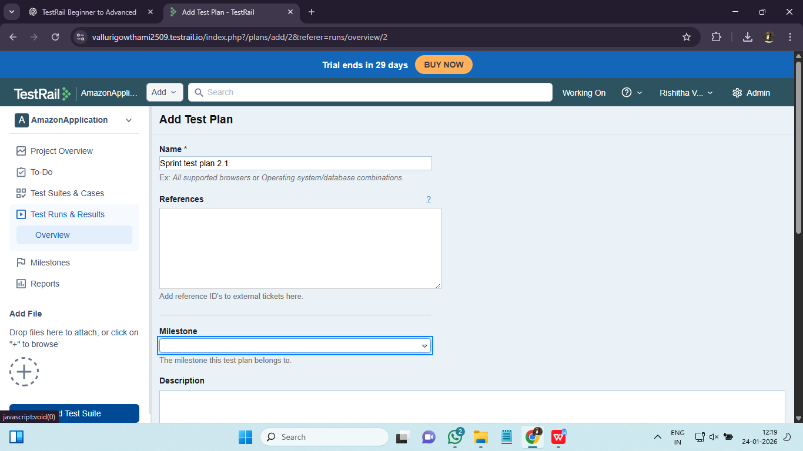

2. Test Runs vs Test Plans :
Aspect | Test Run | Test Plan
Purpose | Execute tests | Organize executions
Scope | One execution set | Multiple runs
Level | Tester | Lead / Manager
Used for | Execution | Release tracking

3. Regression Testing in TestRail :
Regression testing ensures that existing functionality still works after New features, Bug fixes, Enhancements.

TestRail Helps Regression by :
- Reusable test cases
- Repeated test runs
- History of executions
- Trend analysis
Tag regression cases using:
- Type field
- Custom field (Regression = Yes)
Include only critical/high cases for partial regression. Regression in TestRail is about reusability and historical comparison.
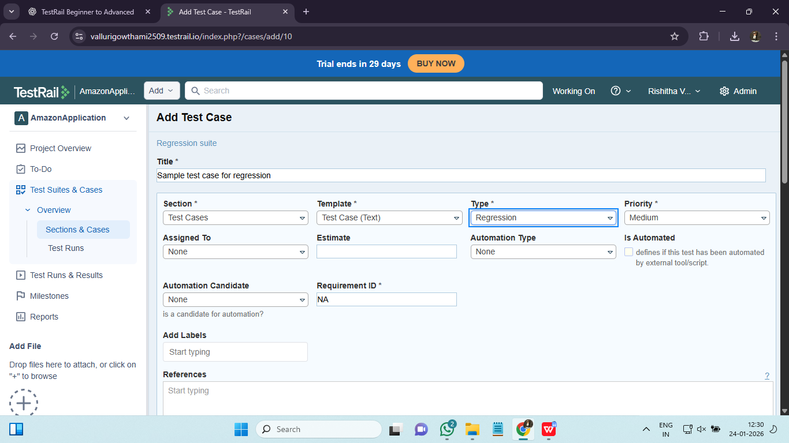

4. Milestones :
A Milestone represents a version, sprint, or release. They are important because they :
- Track progress per release
- Group test plans and runs
- Enable release-level reporting
Milestones provide time-based traceability, not just functional.
Milestone
└── Test Plan
└── Test Runs
└── Executions
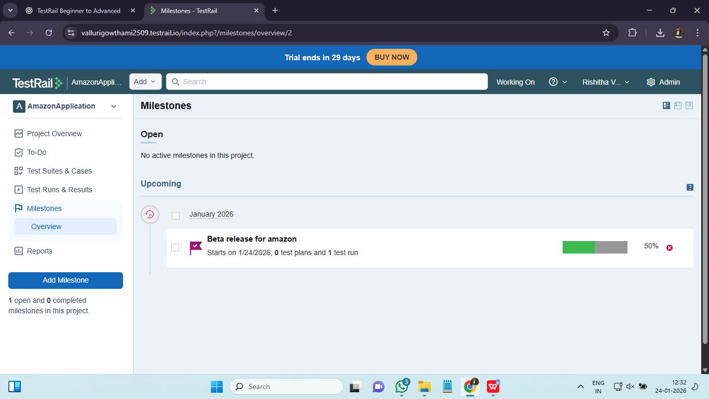

5. Requirements Traceability :
Requirements Traceability ensures Every requirement is tested and Every test has a reason. It is critical because of :
- Audit compliance
- Coverage assurance
- Stakeholder confidence
- Risk reduction

Traceability Flow :
Requirement → Test Case → Test Run → Result

Two Ways in TestRail :

Built-in Requirements (if enabled)

External tool linking (e.g., Jira)
Traceability is not optional in regulated domains (banking, pharma, healthcare).

6. Linking Test Cases to Requirements :

We should Link Test Cases to requirements to Prove coverage, Identify untested requirements, Generate coverage reports. We can link testcases to requirements in 2 ways :

Link Using Requirement ID :

Go to Administration → Custom Fields

Create field: Requirement ID

Add Jira/User Story ID in test case

Link with Jira :

Integrate TestRail with Jira

Add Jira issue key in test case

Enable traceability reports

One requirement → multiple test cases. We should perform Impact analysis when requirement changes. Linking test cases to requirements ensures bidirectional traceability.
